

**MEMORANDUM OF UNDERSTANDING**

This is a document validating an agreement between **MR. OGABOR JOHN AND MR. OKIKIOLA JUWON** for the collaborative of 20% interest over a sum of **ONE HUNDRED AND SEVENTY THOUSAND NAIRA ONLY (N170,000) paid on the 15th of May, 2020.**

There is a binding agreement to pay the initial capital invested, alongside the interest, **TWO HUNDRED AND FOUR THOUSAND NAIRA ONLY (N204,000) on the 15th of June, 2020** by **MR. OGABOR JOHN TO MR. OKIKIOLA JUWON.**

Attached with this document is an evidence of payment by **MR. OKIKIOLA JUWON.**

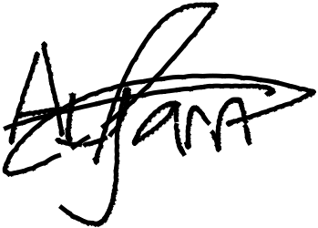

_________________________

_~~__~~_____~~___~~_~~_~~___________



**MR. OKIKIOLA JUWON**

**MR. OGABOR JOHN**

***(CEO, JOHN INVESTMENTS)***